Design Patterns
- Singleton (Creational)
Applied to: SystemSettings. The SystemSettings class handles all hotel security and operational configuration. There should only ever be one instance, multiple instances would cause conflicting configuration between modules. The Singleton design pattern forces this with a private constructor and a static getInstance() method which provides a single access point for all classes through the User class while ensuring precise initialization.
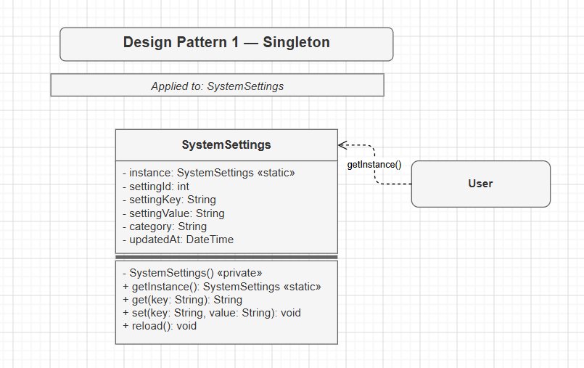

- Factory Method (Creational)
Applied to: User creation by role. The system creates six different user types (Administrator, Receptionist, Manager, FinanceManager, CleaningStaff, Guest) with different permissions. Hard-coding new Receptionist() everywhere in the code base is a violation of OCP (Open Closed Principle). The Factory Method delegates the creation of users to a UserFactory hierarchy, so new roles are added by subclassing a factory, without touching existing code, directly satisfying Single Responsibility and Open/Closed.
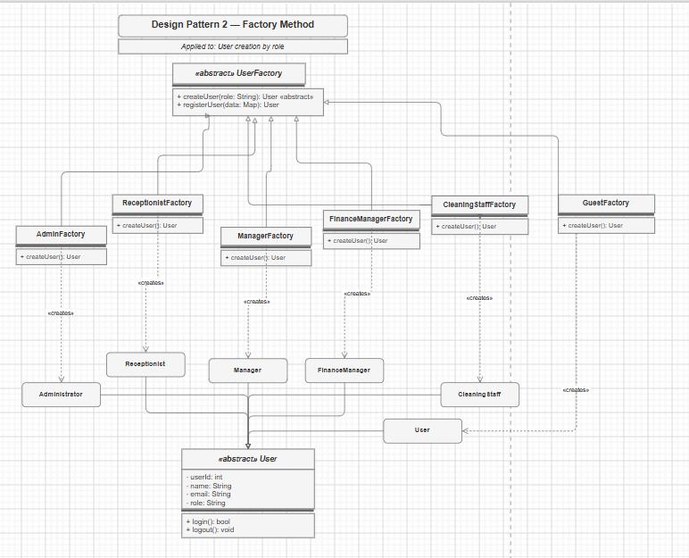

- Observer (Behavioural)
Applied to: Notification system. Multiple actors (Manager, CleaningStaff) must be automatically alerted when a CleaningTask changes status or a MaintenanceReport is submitted. Without the Observer pattern, the publishers would hold direct references to all the receivers and thus be tightly coupled. The Observer pattern introduces a NotificationPublisher interface and an INotificationObserver interface, allowing new recipients to subscribe at runtime without changing the publisher code, satisfying OCP.
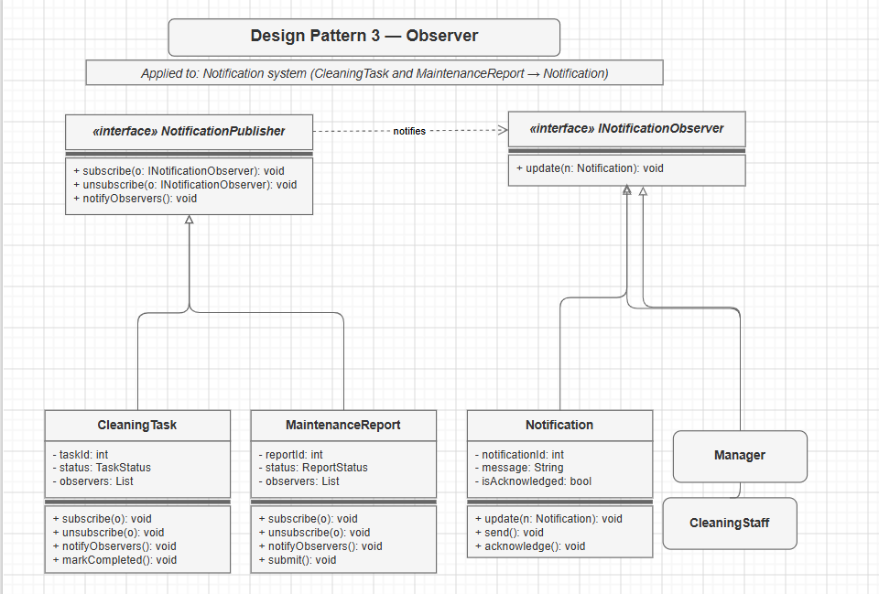

- Strategy (Behavioural)
Applied to: Payment method processing. The hotel takes both cash and card, with a different processing algorithm for each. Embedding all in one process() method with if/else chains is violating OCP. The strategy encapsulates the algorithms (CashPaymentStrategy, CardPaymentStrategy) behind an IPaymentStrategy interface. As the Payment context can take any strategy at run-time, no changes are needed for existing classes when new Payment types are added.

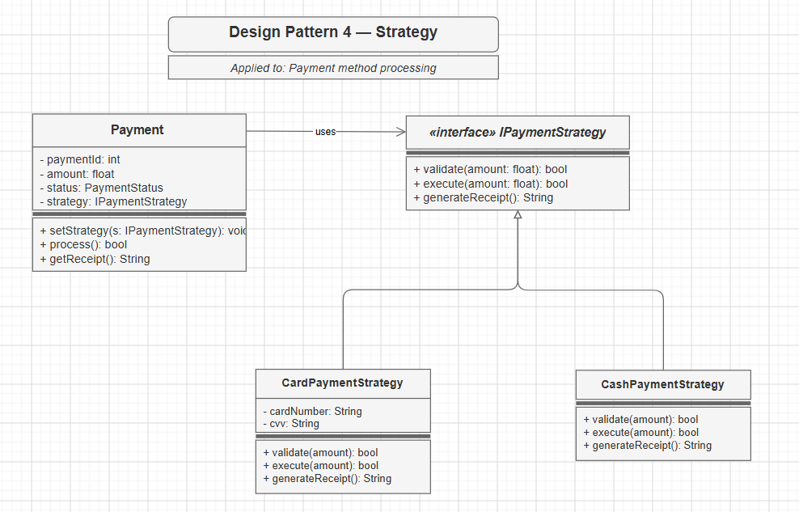

- Façade (Structural)
Applied to: BillingFacade. The billing workflow coordinates five classes (CheckInOut -> Invoice -> Payment -> Refund -> TransactionLog) in a precise sequence. Exposing all of them to Receptionist and FinanceManager directly creates brittle, high-coupling code. The Façade pattern provides three simple operations (completeBilling(), processPayment(), handleRefund()) and hides all subsystem complexity behind them, satisfying the Dependency Inversion Principle and dramatically simplifying client code.

